

Politecnico di Milano

A.A. 2015-2016

Software Engineering 2 Project

**myTaxiService**

**Integration Test Plan Document**

**Ver. 1**

**January 21, 2016**

Alessio Martorana - 860584

1 Introduction 3

1.1 Revision History 3

1.2 Purpose and Scope 3

1.3 List of Definitions and Abbreviations 3

1.4 List of Reference Documents 3

2. Integration Strategy 4

2.1 Entry Criteria 4

2.2 Elements to be integrated 5

2.3 Integration Testing Strategy 5

2.4 Sequence of Component Integration 6

2.4.1 Software Integration Sequence 7

2.4.1 Whole system Integration Sequence 13

3. Individual Steps and Test Description 14

3.1 Authentication subsystem test procedure 14

3.1.1 Integration test case I1 15

3.1.2 Integration test case I2 15

3.1.3 Integration test case I3 15

3.1.4 Integration test case I4 16

3.2 Taxi driver handling subsystem test procedure 17

3.2.1 Integration test case I5 17

3.3 Ride handling subsystem test procedure 18

3.3.1 Integration test case I6 18

3.3.2 Integration test case I7 19

3.4 Dispatching subsystem test procedure 20

3.4.1 Integration test case I8 20

3.4.2 Integration test case I9 21

3.4.3 Integration test case I10 21

3.4.4 Integration test case I11 22

3.5 Whole system test procedure 23

4. Tools and test Equipment required 24

Manual testing 24

Junit: http://junit.org (or equivalent testing tool for used programming language) 24

Apache JMeter: http://jmeter.apache.org 24

5. Program Stubs and Test Data Required 25

# 1 Introduction

## 1.1 Revision History

No revisions of the document at the moment.

## 1.2 Purpose and Scope

This document describes the test plan for components integration.

The purpose of the document is to test module interactions and interfaces with which components described in DD interacts. This document is brought to the attention to every person involved in integration test phase.

The system implements a taxi driver rides handling, its main function is to permit the exchange of necessary data to handle request taxi rides between users and taxi drivers, users can interface to the system either with a web application or a mobile app, taxi drivers can serve request through a specific mobile app.

## 1.3 List of Definitions and Abbreviations

* **myTaxiService:** The name of the system developed
* **RASD:** Requirement Analysis and Specification Document
* **DD:** Design Document

## 1.4 List of Reference Documents

* **Assignment 1,2,3 and 4:** Assignments for the various phase of the project given to me by the professor.
* **RASD:** The Requirement Analysis and Specification Document
* **DD:** The Design Document
* **Junit javadoc:** [**http://junit.org/javadoc/latest/index.html**](http://junit.org/javadoc/latest/index.html)
* **JMeter javadoc:** [**http://jmeter.apache.org/api/index.html**](http://jmeter.apache.org/api/index.html)

# 2. Integration Strategy

## 2.1 Entry Criteria

Before integration testing may begin, the following documents must be released:

* TheDesign Document (DD)
* The Requirement Analysis and Specification Document (RASD)
* The Integration Test Plan Document (ITPD), that is this document

Before integration testing may begin, is also needed that:

* The single components involved have been delivered
* Involved single components have been already unit tested and unit testing test reports concerning these components have been delivered
* Driver for the integration test have been delivered
* Input data for the integration test has been delivered

## 2.2 Elements to be integrated

Referring to the DD, the components to be integrated and integration tested are the following:

* **myTaxiService web application**
* **myTaxiService users mobile app**
* **myTaxiService taxis mobile app**
* **Controller**
* **Authenticator**
* **Authentication checker**
* **Logged clients information handler**
* **Dispatcher**
* **Ride request handler**
* **Taxi driver handler**

## 2.3 Integration Testing Strategy

The integration testing approach chosen is the “Bottom-up” one, because due to the non-excessive subsystems dimension and the modularity architecture of the system, this strategy is considered as a good approach.

The “Bottom-up” integration testing strategy starts from the bottom level of the system, trying to test the integration of the leaves of the “uses” hierarchy, and going up and up to the top level of the system as lowest levels become already tested.

“Bottom-up” integration testing strategy needs some additional components called “drivers”, which are to interface with each subsystems module, passing the test data to the component of the subsystem to be tested and printing results.

## 2.4 Sequence of Component Integration

Here the components and subsystems integration sequence is described, at first a diagram is presented, in which the arrows have two meanings: the arrows with an ID (ex. I1) between brackets represent the integration sequence of the objects, in the sense that if object A is placed before the arrow and object B is placed after the arrow, object B will be integrated after object A and the ID represent the identifier of the integration test that has to be done, the arrows with “TEST DATA” instead represent the calls of the modules by a specific driver for each subsystem identified.

As the integration testing strategy is bottom up, every step of components integration in subsystems is tested with a driver as shown in the following general scheme

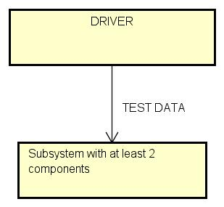

From the figure can be seen that, as the components are supposed to be already unit tested, the subsystem tested is considered to be at least of two components.

Under each diagram a table with the details on components integration is presented, ordered by ID: in this table the arrow represents only the order of interactions of an object by another one, so – for example - if object A is placed before the arrow and object B is placed after the arrow, object A will interact with object B calling one of its methods/functions; as can be seen, calls by driver are notified; if more than one object interacts with the object after the arrow, the objects before the arrow are listed separated by comma. The column “paragraph” indicates the paragraph in this document where the description of the type of tests for the integration are stated.

### 2.4.1 Software Integration Sequence

In this paragraph the software components integration sequence is described for each subsystem.

#### 2.4.1.1 Authentication subsystem

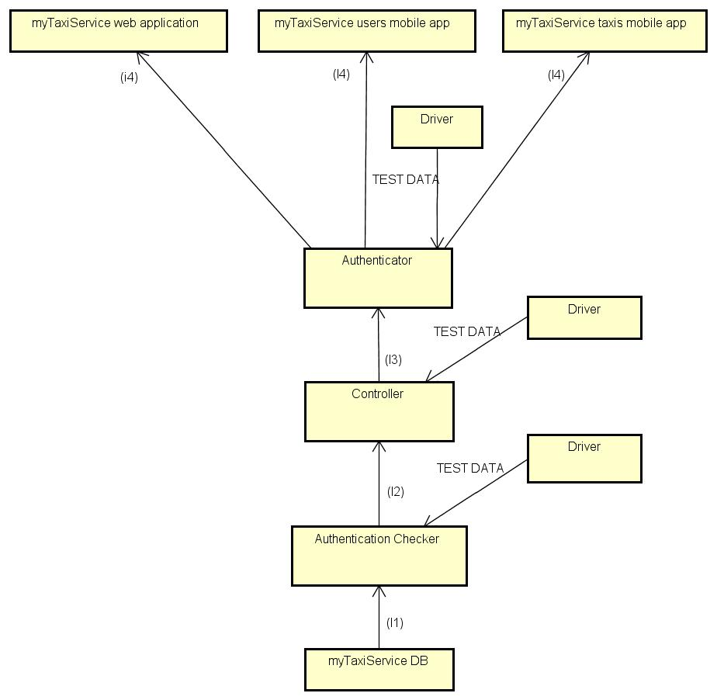

|  |  |  |
| --- | --- | --- |
| **ID** | **Integration Test** | **Paragraph** |
| I1 | *Driver* → Authentication Checker → myTaxiService DB | 3.1.1 |
| I2 | *Driver* → Controller → Authentication Checker | 3.1.2 |
| I3 | *Driver* → Authenticator → Controller | 3.1.3 |
| I4 | MyTaxiService web application, MyTaxiService users mobile app, MyTaxiService taxis mobile app → Authentication Checker | 3.1.4 |

#### 2.4.1.2 Taxi driver handling subsystem

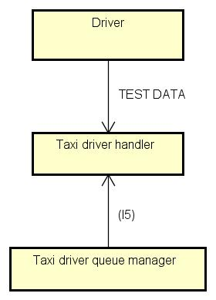

|  |  |  |
| --- | --- | --- |
| **ID** | **Integration Test** | **Paragraph** |
| I5 | *Driver*→ Taxi driver handler → Taxi driver queue manager | 3.2.1 |

#### 2.4.1.3 Ride handling subsystem

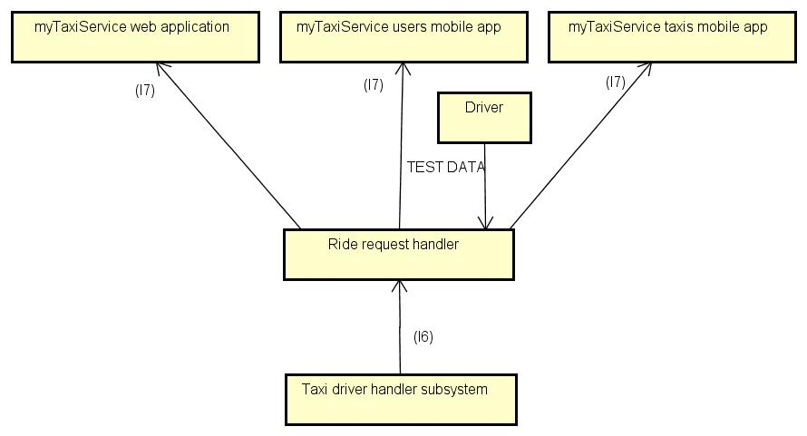

|  |  |  |
| --- | --- | --- |
| **ID** | **Integration Test** | **Paragraph** |
| I6 | *Driver*→ Ride request handler → Taxi driver handler subsystem | 3.3.1 |
| I7 | MyTaxiService web application, MyTaxiService users mobile app, MyTaxiService taxis mobile app → Authentication Checker | 3.3.2 |

#### 2.4.1.5 Dispatching subsystem

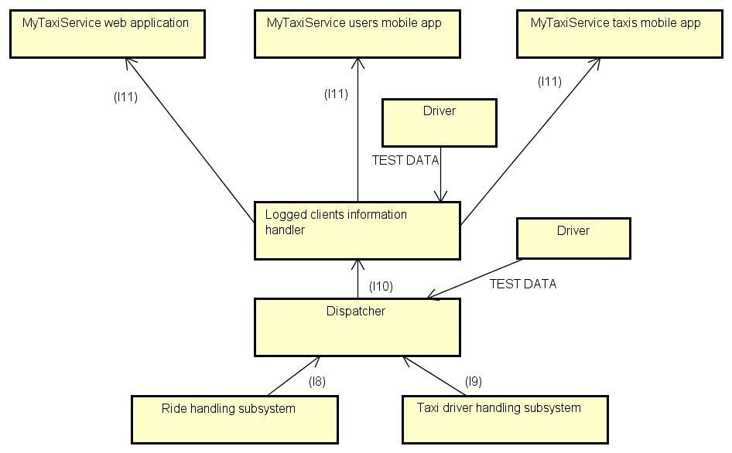

|  |  |  |
| --- | --- | --- |
| **ID** | **Integration Test** | **Paragraph** |
| I8 | *Driver*→ Dispatcher → Ride request handler subsystem | 3.4.1 |
| I9 | *Driver*→ Dispatcher → Taxi driver handling subsystem | 3.4.2 |
| I10 | *Driver*→ Logged clients information handler → Dispatcher | 3.4.3 |
| I11 | MyTaxiService web application, MyTaxiService users mobile app, MyTaxiService taxis mobile app → Ride request handler | 3.4.4 |

**asda**

## 2.4.1 Whole system Integration Sequence

Due to the fact that the creation of subsystems shown above proceeded using smaller subsystems to create bigger ones and to the high modularity of the system, creating the subsystems the whole system is already assembled as a top level subsystem. At this time, the final test of the whole system can be performed as described in paragraph 3.5.  
The following diagram shows the entire system as assembled connecting its subsystems.

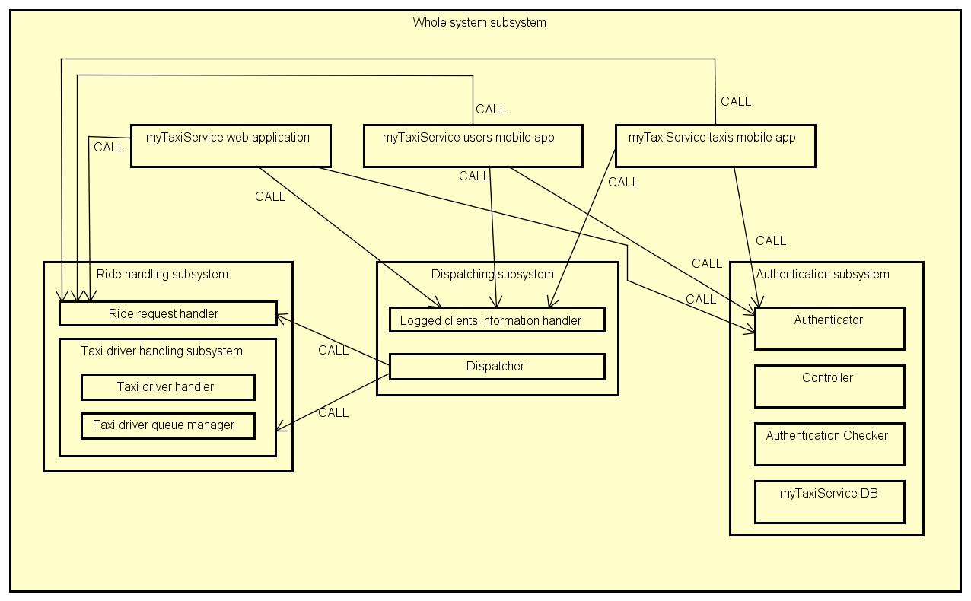

# 3. Individual Steps and Test Description

In this section of the document the type of tests that will be used in the integration test will be described. For each subsystem the test procedure is reported and the integration steps are identified, also, for each specific step of the integration, relative sub-steps are described.

## 3.1 Authentication subsystem test procedure

|  |  |
| --- | --- |
| **Test procedure identifier** | AS-TP |
| **Purpose** | This test procedure verifies whether the Authentication subsystem:   * Correctly handles clients input * Correctly stores user information in the database * Correctly checks log-in information * Correctly communicates registration operation result to clients * Correctly communicates log-in operation result to clients |
| **Procedure steps** | Execute I1,I2,I3 and I4 in this precise order |

### 3.1.1 Integration test case I1

|  |  |
| --- | --- |
| **Test case identifier** | I1 |
| **Test items** | *Driver* → Authentication Checker → myTaxiService DB |
| **Input specification** | Create a typical input for Authentication Checker |
| **Output specification** | Check if the correct method/functions are called - and behave as expected - in myTaxiService DB |
| **Environmental needs** | Authentication checker driver |

### 3.1.2 Integration test case I2

|  |  |
| --- | --- |
| **Test case identifier** | I2 |
| **Test items** | *Driver* → Controller → Authentication Checker |
| **Input specification** | Create a typical input for Controller |
| **Output specification** | Check if the correct method/functions are called - and behave as expected - in Authentication Checker |
| **Environmental needs** | I1 succeded, Controller driver |

### 3.1.3 Integration test case I3

|  |  |
| --- | --- |
| **Test case identifier** | I3 |
| **Test items** | *Driver* → Authenticator → Controller |
| **Input specification** | Create a typical input for Authenticator |
| **Output specification** | Check if the correct method/functions are called - and behave as expected - in Controller |
| **Environmental needs** | I2 succeded, Authenticator driver |

### 3.1.4 Integration test case I4

|  |  |
| --- | --- |
| **Test case identifier** | I4 |
| **Test items** | MyTaxiService web application, MyTaxiService users mobile app, MyTaxiService taxis mobile app → Authentication Checker |
| **Input specification** | Create typical inputs for MyTaxiService web application, MyTaxiService users mobile app and MyTaxiService taxis mobile app |
| **Output specification** | Check if the correct method/functions are called - and behave as expected - in Authentication Checker |
| **Environmental needs** | I3 succeded |

## 3.2 Taxi driver handling subsystem test procedure

|  |  |
| --- | --- |
| **Test procedure identifier** | TDHS-TP |
| **Purpose** | This test procedure verifies whether the Taxi driver handling subsystem:   * Correctly handles taxi driver’s position input * Correctly handles Ride requests inputs * Correctly outputs taxi driver’s data (ID, position, availability etc…) * Correctly (fairly) manages taxi drivers queue |
| **Procedure steps** | Execute I5 |

### 3.2.1 Integration test case I5

|  |  |
| --- | --- |
| **Test case identifier** | I5 |
| **Test items** | *Driver*→ Taxi driver handler → Taxi driver queue manager |
| **Input specification** | Create a typical input for Taxi driver handler |
| **Output specification** | Check if the correct method/functions are called - and behave as expected - in Taxi driver queue manager |
| **Environmental needs** | Taxi driver handler driver |

## 3.3 Ride handling subsystem test procedure

|  |  |
| --- | --- |
| **Test procedure identifier** | RHS-TP |
| **Purpose** | This test procedure verifies whether the Rie handling subsystem:   * Correctly handles clients input * Correctly handles ride requests client inputs * Correctly outputs ride request results to clients |
| **Procedure steps** | Execute I6 and I7 in this precise order |

### 3.3.1 Integration test case I6

|  |  |
| --- | --- |
| **Test case identifier** | I6 |
| **Test items** | *Driver*→ Ride request handler → Taxi driver handler subsystem |
| **Input specification** | Create a typical input for Ride request handler |
| **Output specification** | Check if the correct method/functions are called - and behave as expected - in Taxi driver handler subsystem |
| **Environmental needs** | Ride request handler driver |

### 3.3.2 Integration test case I7

|  |  |
| --- | --- |
| **Test case identifier** | I7 |
| **Test items** | MyTaxiService web application, MyTaxiService users mobile app, MyTaxiService taxis mobile app → Authentication Checker |
| **Input specification** | Create typical inputs for MyTaxiService web application, MyTaxiService users mobile app and MyTaxiService taxis mobile app |
| **Output specification** | Check if the correct method/functions are called - and behave as expected - in Authentication checker |
| **Environmental needs** | I6 succeded |

## 3.4 Dispatching subsystem test procedure

|  |  |
| --- | --- |
| **Test procedure identifier** | DS-TP |
| **Purpose** | This test procedure verifies whether the Dispatching subsystem:   * Correctly checks if the user is authenticated * Correctly dispatches taxi driver position to the server of the right zone * Correctly communicates the right server address to client applications * Correctly dispatches user identity to the server of the right zone |
| **Procedure steps** | Execute I8, I9 (in any order) and then I10 and I11 in this precise order |

### 3.4.1 Integration test case I8

|  |  |
| --- | --- |
| **Test case identifier** | I8 |
| **Test items** | *Driver*→ Dispatcher → Ride request handler subsystem |
| **Input specification** | Create a typical input for Dispatcher that will require the use of Ride request handler subsystem |
| **Output specification** | Check if the correct method/functions are called - and behave as expected - in Ride request handler subsystem |
| **Environmental needs** | Dispatcher driver |

### 3.4.2 Integration test case I9

|  |  |
| --- | --- |
| **Test case identifier** | I9 |
| **Test items** | *Driver*→ Dispatcher → Taxi driver handling subsystem |
| **Input specification** | Create a typical input for Dispatcher that will require the use of Taxi driver handling subsystem |
| **Output specification** | Check if the correct method/functions are called - and behave as expected - in Taxi driver handling subsystem |
| **Environmental needs** | Dispatcher driver |

### 3.4.3 Integration test case I10

|  |  |
| --- | --- |
| **Test case identifier** | I10 |
| **Test items** | *Driver*→ Logged clients information handler → Dispatcher |
| **Input specification** | Create a typical input for Logged clients information handler |
| **Output specification** | Check if the correct method/functions are called - and behave as expected - in Logged clients information handler |
| **Environmental needs** | I8 and I9 succeded |

### 3.4.4 Integration test case I11

|  |  |
| --- | --- |
| **Test case identifier** | I11 |
| **Test items** | MyTaxiService web application, MyTaxiService users mobile app, MyTaxiService taxis mobile app → Logged clients information handler |
| **Input specification** | Create typical inputs for MyTaxiService web application, MyTaxiService users mobile app and MyTaxiService taxis mobile app |
| **Output specification** | Check if the correct method/functions are called - and behave as expected - in Logged clients information handler |
| **Environmental needs** | I10 succeded |

## 3.5 Whole system test procedure

|  |  |
| --- | --- |
| **Test procedure identifier** | WS-TS |
| **Purpose** | This test procedure verifies whether the Whole system   * Correctly handles users authentication and registration * Correctly handles ride requests |
| **Procedure steps** | Create typical inputs for myTaxiService system from the clients applications and check if the system behaves as expected |

# 4. Tools and test Equipment required

Here the tools that are to be used for testing are stated, together with a brief description of how to use them for testing this system.

## Manual testing

**Why and how to use it:** For the creation of specific drivers for each different subsystem at each step in which a they are needed and in the interaction with MyTaxiService web application, MyTaxiService users mobile and app,MyTaxiService taxis mobile app in order to test, like if the tester was the end user, the features of the specific subsystem.

## Junit: <http://junit.org> (or equivalent testing tool for used programming language)

**Why and how to use it:** To verify behavior of subsystems with specific assertion statements; an example of use is the creation of a testing suite of classes to create the subsystem and to verify values of some variables with assertion lines.

## Apache JMeter: <http://jmeter.apache.org>

**Why and how to use it:** To verify accomplishment of performance requirements stated in RASD. The use consists in the setting up of apposite testing plans to simulate scenarios in which the system has to react in the specified bounds of performance.

# 5. Program Stubs and Test Data Required

As already specified in sections 1,2 and 3 of this document, creation of specific drivers for each subsystem at each step at which it is needed and the test data is the input data specified in the test procedures.

# 6. Appendix

For the creation of this document I spent 30 hours.